EXECUTION DIRECTIVE — READ FIRST
You are being given a complete specification for a document-generation task.
EXECUTE THIS TASK NOW.
Do not summarize these instructions.
Do not explain what you are going to do.
Do not critique the prompt.
Do not ask the user to copy or paste the content elsewhere.
Do not return the worksheet as plain text.
Your task is to create the completed student worksheet as a new Microsoft Word (.docx) document.
Read and follow all instructions in this document before generating the file.
REQUIRED OUTPUT
Your final output must be:
ONE completed downloadable Microsoft Word (.docx) file containing the worksheet.
The Word document must contain:
- The exact embedded decision-guide image supplied in this prompt document.
- All student problems.
- All required student response spaces.
- The complete answer key.
- All formatting and structural requirements specified below.
After creating the document, provide the completed .docx file to the user.
Do not substitute a text response for the Word document.
EMBEDDED IMAGE REQUIREMENT
This prompt document contains an embedded image showing the normal-curve decision guide.
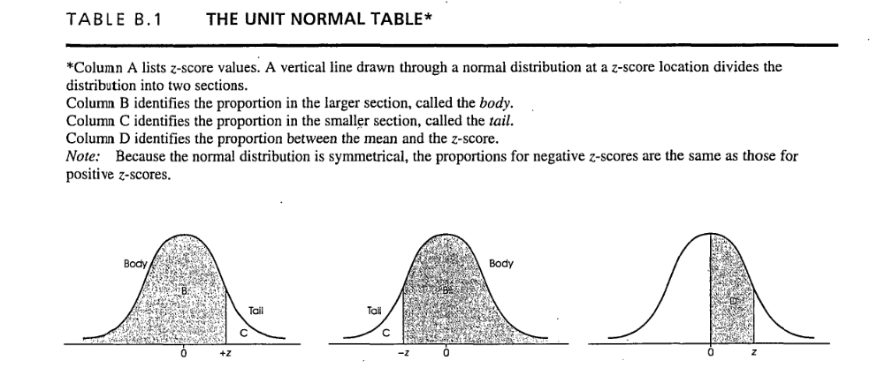
You must use the exact embedded image supplied with this document.
- Extract the embedded image from this prompt document.
- Do not redraw the image.
- Do not recreate the image using shapes, text, or a newly generated graphic.
- Do not substitute another image.
- Preserve the supplied image itself.
- Place the image immediately before every student problem.
- Students should be able to refer to the image while completing every problem.
TASK
Create a student worksheet for an introductory Behavioral Statistics course.
The worksheet should focus on:
- Converting raw scores to z-scores.
- Determining whether the z-score is positive or negative.
- Selecting the appropriate graph from the supplied decision-guide image.
- Determining whether the desired probability is represented by the shaded Body or unshaded Tail.
- Using a z-table to find the requested probability.
Students must complete every step themselves.
IMPORTANT Z-TABLE ASSUMPTIONS
Assume the supplied image and z-table use the following conventions:
- The left graph represents a positive z-score.
- The middle graph represents a negative z-score.
- The shaded region represents the Body.
- The unshaded region represents the Tail.
Students are using a z-table with columns for:
- z-score
- Body
- Tail
- Area between the mean and z
Do not recreate or redraw the supplied image.
DO NOT INCLUDE
Do not include:
- Learning objectives
- Student name fields
- Date fields
- Class information
- Introductory explanations
- Instructor notes
- Areas-between-two-scores problems
- Any answer hints before the answer key
The worksheet should begin immediately with the supplied image followed by Problem 1.
PROBLEMS
Create 10 applied behavioral-science research problems.
Use realistic contexts such as:
- Test anxiety
- Depression symptoms
- Memory performance
- Academic achievement
- Sleep quality
- Stress levels
- Social connectedness
- Job satisfaction
- Cognitive performance
- Motivation
Each problem must provide:
- Mean (μ)
- Standard deviation (σ)
- Raw score (X)
Students must calculate all z-scores themselves.
Use values that produce relatively clean z-scores such as:
- ±0.50
- ±1.00
- ±1.25
- ±1.50
- ±2.00
Use approximately half positive and half negative z-scores.
Include a mixture of:
- Area Above a Score
- Area Below a Score
Do not include any areas-between-two-scores problems.
REQUIRED PROBLEM FORMAT
Every problem must use this exact sequence.
Research Scenario
Provide a brief behavioral-science research scenario.
Provide:
- Mean (μ)
- Standard deviation (σ)
Then ask either:
What proportion of participants scored ABOVE X?
or:
What proportion of participants scored BELOW X?
Step 1: Compute the z-Score
Use:
z = (X − μ) / σ
Provide space for students to show their work.
Then:
z = ___________________
Step 2: Determine Which Graph to Use
Ask:
Is your z-score:
□ Positive
□ Negative
Then:
Based on your answer, which graph at the top of this problem should you use?
□ Left graph (positive z)
□ Middle graph (negative z)
Step 3: Determine Which Region Represents the Desired Probability
Ask:
The problem asks for:
□ Area Above the Score
□ Area Below the Score
Then:
On the graph you selected, should you use:
□ Shaded region (Body)
□ Unshaded region (Tail)
Step 4: Locate the z-Score on the Table
Include:
- Use your z-score table (located in Canvas in Lesson 7 at the top)
- Find the z-score column.
- Locate the z-score you calculated in Step 1.
- Move across the row to the appropriate column (Body or Tail).
- Record the area from the table.
Then provide:
Area = ___________________
Include ample blank space for student responses.
At the end of every problem, remind students to refer to the decision-guide image immediately above that problem.
ANSWER KEY
After all student problems, begin a new page with:
====================================================
ANSWER KEY
====================================================
Do not provide any answers before this section.
Do not use probability notation.
Do not write answers in forms such as:
P(X > 60) = .1587
or
P(X < 60) = .8413
Instead, write the answers in complete words.
For every problem, explicitly provide:
- Formula substitution using the actual numbers from the problem.
- Complete arithmetic steps for the computed z-score
- Positive or negative determination
- Which graph should be selected (left or middle)
- Whether the shaded or unshaded region should be used
- Whether the Body or Tail value is required
- The z-table area
- The final probability in complete words

FORMATTING
Make the worksheet look like a professional classroom handout.
Requirements:
- Clear headings
- Consistent typography
- Ample response space
- Easy-to-follow numbered steps
- Clear separation between problems
- The supplied decision-guide image clearly visible
- Answer key beginning on a new page
- No answers visible in the student portion
FINAL QUALITY CHECK
Before returning the file, verify that:
- The exact supplied embedded image appears at the top of the worksheet.
- The image also appears immediately before every problem.
- There are 10 student problems.
- Approximately half produce positive z-scores and half negative z-scores.
- Both ABOVE and BELOW questions are included.
- Every problem contains μ, σ, and X.
- Every problem contains all four required student steps.
- Every problem has sufficient response space.
- The answer key contains actual numerical answers.

- No answer hints appear before the answer key.
- No probability notation is used in the answer key.
- The answer key contains all 8 required elements for every problem.
- The final output is a .docx file.
Now execute the task and create the completed Word document.

